A Project Report on
QUIZORIA

By
Shreya Chaudhari & Rahul Shinde
MCA – I, SEM – I
2025-26

To
Savitribai Phule Pune University,Pune

In Partial Fulfillment of the Degree of
Master in Computer Application (M. C. A.)

Under The Guidance Of
Prof. Aishwarya Pawar

Suryadatta Group of Institutes, Pune
Suryadatta Institute of Management and Mass Communication (SIMMC)

Date:-

CERTIFICATE

This is to certify that Mr. / Ms. Shreya Chaudhari & Rahul Shinde, has successfully completed his/her
project work entitled “Quizoria” in partial fulfillment of MCA – I Semester-I program
for the year A.Y. 2025-26. He / She have worked under our guidance and direction.

Prof. Aishwarya Pawar
(Project Guide) HOD - MCA,SGI

Examiner 1 Examiner 2

Date :
Place :

Acknowledgment

We are the student of MCA first year. Here by we express our thanks to our project guide for allowing us to do the project on Quizoria. This project work has been the most exciting part of our learning experience which would be an asset for our future carrier. We would especially like to thank our guide and mentor Prof. Aishwarya Pawar, who constantly guided us in developing, pushing us to search for more answers to her numerous questions. Also I would like to thank Dr. Rupali Dahake & Prof. Apurva Patil, project coordinators for their support. As a building block of MCA Department, I thank Dr. Manisha Kumbhar, HOD, MCA Department for her continuous support and help. We are grateful to many classmates who contributed their suggestions. Their hard work and examples push us to limits of our capability and encourage us daily.

Thank You

Student Name : Shreya Chaudhari & Raul Shinde

Index

Chapter | Page number
CHAPTER 1 : INTRODUCTION
1.1 Existing System
1.2 Need for System
1.3 Operating Environment Hardware and Software
CHAPTER 2 : PROPOSED SYSTEM
2.1 Proposed System (Introduction of system)
2.2 Module specifications (Scope)
2.3 Objectives of System
CHAPTER 3 : ANALYSIS & DESIGN
3.1 Use Case Diagrams
3.2 Activity Diagram
3.3. Sequence Diagram
3.4 Class Diagram
3.5 Module Hierarchy Diagram
3.6 Table specifications (Database design)
3.7 Data dictionary
CHAPTER 4 : USER MANUAL
4.1 User Interface Screens (Input)
4.2 Output Screens with data
4.3 Data Reports
4.4 Test Procedures and cases
4.5 Sample program code
4.6 Limitations and Bibliography

CHAPTER 1: INTRODUCTION

  - Existing System
- Our application is designed to test your knowledge, challenge your thinking, and provide entertainment.
- Our application is designed to provide an immersive and engaging quiz experience.
- Users can participate in various quiz formats, including:
  - Multiple-choice questions
  - True or False
  - Open-ended questions.
- The Application Provide Real-time scoring and leaderboard rankings.
- Provide an interactive and engaging platform for learning programming concepts and languages
- Offer a comprehensive range of quizzes covering various programming languages, like HTML, CSS, PHP, ANDROID.
- Make programming learning fun, easy, and accessible to learners of all levels and backgrounds

  - Need for System

- Convenience: This website makes it easy to access quizzes on various computer languages, such as HTML, CSS, Java, and Android. Available 24/7, users can practice and test their knowledge at their convenience. The platform ensures up-to-date quizzes and resources, enhancing user accessibility and learning flexibility.

- Variety: The website offers a wide range of quizzes, covering different programming languages, topics, difficulty levels, and types of questions (multiple choice, true/false). This variety ensures that users can find quizzes tailored to their specific language of interest, skill level, and learning goals.

- Information: Each quiz is designed to provide clear, informative funfact. Users will get detailed explanations of correct and incorrect answers, along with hints and resources to improve their understanding. This ensures that users can make informed decisions about where they need to focus their learning efforts.

- User Reviews: User reviews for each quiz and topic will be available, providing insights into how well the content works for others.

- Learning Opportunities: The platform encourages continual learning through quizzes, progress tracking. Users can track their improvement over time, get tailored quiz suggestions, and access learning resources.

1.3 Operating Environment Hardware and Software

1. Hardware Requirements:
Server Hardware:
- Processor: Modern multi-core processor (e.g., Intel Xeon, AMD Ryzen)
- RAM: Minimum 2 GB (4 GB or more recommended for better performance)
- Storage: SSD preferred; starting with at least 20 GB for web files and database (scalable based on expected traffic and data)

Server-Side Software:
- Operating System: Linux-based OS (e.g., Ubuntu, CentOS) or Windows Server
- Application Server: Apache Tomcat / Jetty / WildFly
- Java Development Kit (JDK): Version 11 or higher (LTS recommended, e.g., JDK 17)
- Database: MySQL 5.7 or higher (or MariaDB/PostgreSQL as an alternative)
- Database Management Tool: MySQL Workbench / pgAdmin

CHAPTER 2 : PROPOSED SYSTEM

2.1 Proposed System (Introduction of system)

1.Quiz Creation and Management
- Admin panel to create, update, and delete quizzes.
- Support for multiple question types, including:
  - Multiple Choice
  - True/False
  - Fill-in-the-Blank
- Ability to organize questions by categories and difficulty levels.

2. Quiz Participation
- User-friendly interface for browsing and selecting quizzes based on:
  - Category
  - Difficulty level
- Built-in timer for each question or for the entire quiz to increase engagement and challenge.

3. Score Calculation and Feedback
- Automatic score calculation after quiz completion.
- Display of:
  - Total score
  - Correct answers
  - Detailed explanations to help users learn from mistakes.

4. Leaderboards and Gamification
- Real-time leaderboards showing top-performing users.
- Badges, rewards, and milestones to motivate continuous learning and participation.

2.2 Module specifications (Scope)
Modules:
- Home: Home module typically serves as the main landing page that welcomes visitors and provides an overview of what the website offers.
- User Registration: Allows users to create an account and register for the quiz.
- Login: The Login module is where users can log in to their accounts securely
- User Profile: Displays user information, such as name, email, and quiz history.
- Leaderboard: Displays the top-scoring users for a particular quiz.

Scope :
- Add more topics: Consider adding more programming languages, frameworks, or technologies to cater to a broader audience.

- Personalized feedback and analytics: Implement a system that provides personalized feedback and analytics to help users identify areas for improvement.

2.3 Objectives of System

1. Efficient Quiz Registration and Management
Objective:
Develop a user-friendly quiz system where users can easily browse coding quizzes, choose difficulty levels, and participate without friction.
Impact:
Enhances user engagement by simplifying the process of discovering, selecting, and attempting coding challenges, resulting in a more interactive learning experience.

2. Secure User Authentication
Objective:
Implement a secure login and registration system that allows users to maintain personalized accounts, track quiz progress, store results, and receive tailored quiz recommendations.
Impact:
Protects user data through secure authentication while enabling long-term progress tracking and personalized performance insights.

3. Efficient Data Management with MySQL
Objective:
Use MySQL to manage user data, quiz scores, quiz attempts, and dynamic quiz content effectively.
Impact:
Creates a scalable, reliable database structure that supports efficient quiz management, performance tracking, and accurate leaderboard rankings.

CHAPTER 3 : ANALYSIS & DESIGN

3.1 Use Case Diagrams

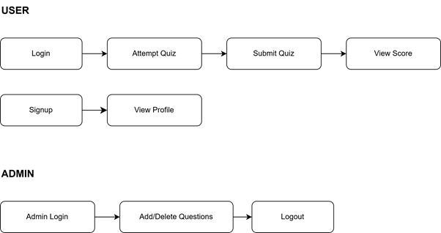

3.2 Activity Diagram
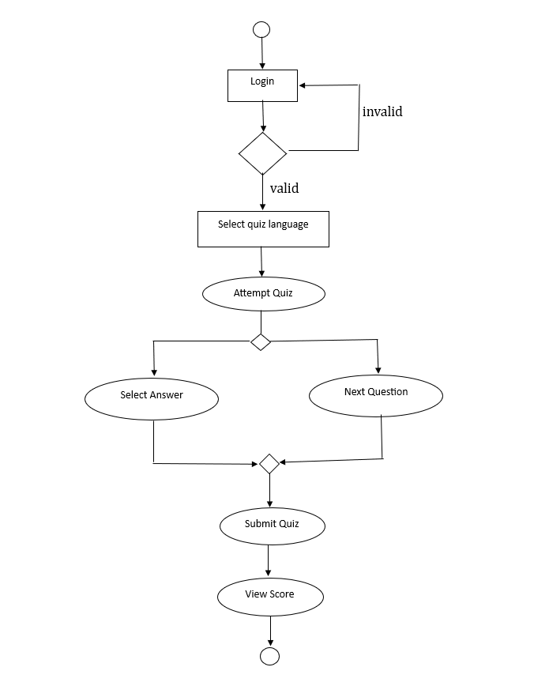
3.3. Sequence Diagram
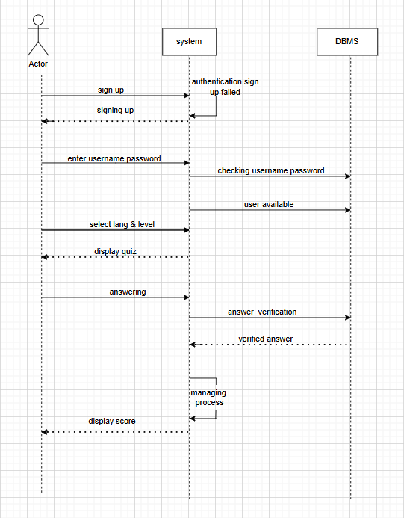
3.4 Class Diagram

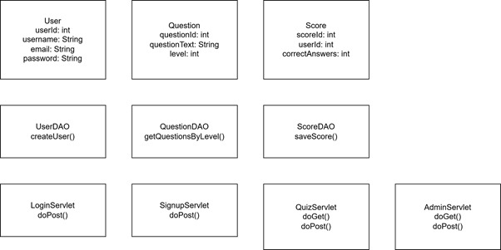
3.5 Module Hierarchy Diagram

Quizoria (Main Module)
│
├── User Module
│ ├── Signup
│ ├── Login
│ ├── Profile
│ ├── Quiz Levels
│ └── Quiz Attempt
│
├── Admin Module
│ ├── Admin Login
│ ├── Add Question
│ ├── Delete Question
│ └── View Questions
│
└── Database Module
├── User Table
├── Question Table
└── Score Table

3.6 Table specifications (Database design)

3.7 Data dictionary

1. Users
Column Name | Data Type | Description
user_id | INT (Primary Key) | Unique identifier for each user.
username | VARCHAR(50) | Username chosen by the user.
email | VARCHAR(100) | User's email address.
password | VARCHAR(100) | Hashed password for authentication.
registration_date | DATETIME | Date and time when the user registered.

2. Languages
Column Name | Data Type | Description
language_id | INT (Primary Key) | Unique identifier for each coding language.
language_name | VARCHAR(50) | Name of the coding language (e.g., Python, Java).

3. Levels
Column Name | Data Type | Description
level_id | INT (Primary Key) | Unique identifier for each level.
level_name | VARCHAR(50) | Name of the level (e.g., Beginner, Intermediate).
description | TEXT | Description of the level's difficulty.

4. Quizzes
Column Name | Data Type | Description
quiz_id | INT (Primary Key) | Unique identifier for each quiz.
quiz_title | VARCHAR(100) | Title of the quiz.
language_id | INT (Foreign Key) | Reference to the coding language.
level_id | INT (Foreign Key) | Reference to the quiz level.
total_questions | INT | Number of questions in the quiz.

5. Questions
Column Name | Data Type | Description
question_id | INT (Primary Key) | Unique identifier for each question.
quiz_id | INT (Foreign Key) | Reference to the quiz.
question_text | TEXT | The text of the question.
correct_answer | VARCHAR(255) | The correct answer to the question.
points | INT | Points awarded for answering correctly.

6. User_Responses
Column Name | Data Type | Description
response_id | INT (Primary Key) | Unique identifier for each response.
user_id | INT (Foreign Key) | Reference to the user.
quiz_id | INT (Foreign Key) | Reference to the quiz.
question_id | INT (Foreign Key) | Reference to the question.
selected_answer | VARCHAR(255) | Answer chosen by the user.
is_correct | BOOLEAN | Indicates if the answer was correct.

CHAPTER 4 : USER MANUAL

4.1 User Interface Screens (Input)

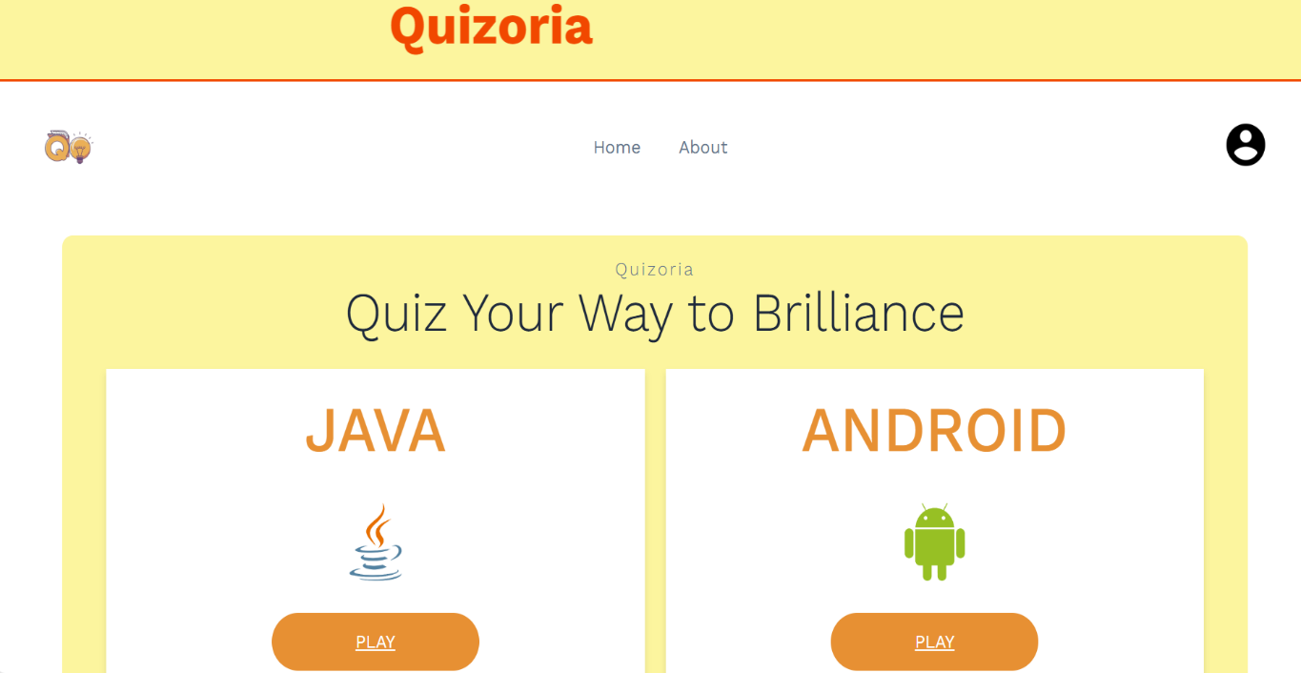

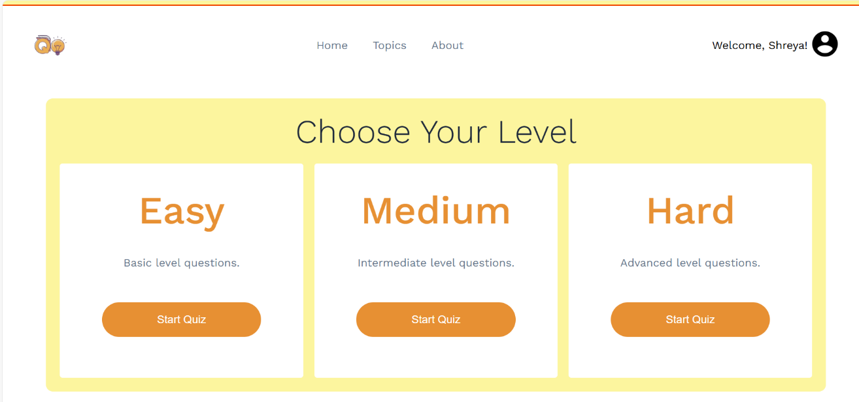
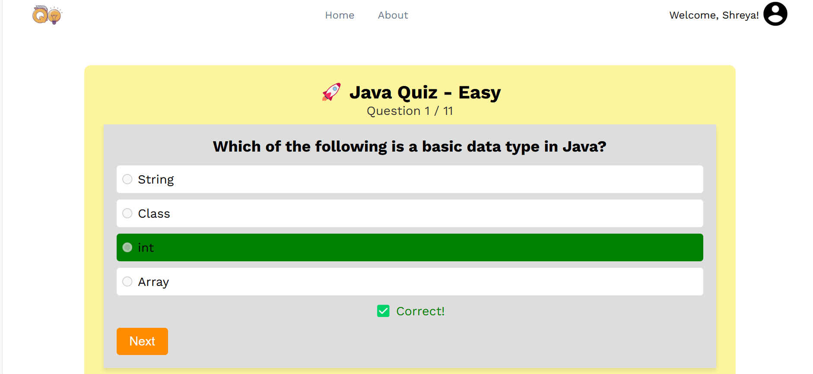

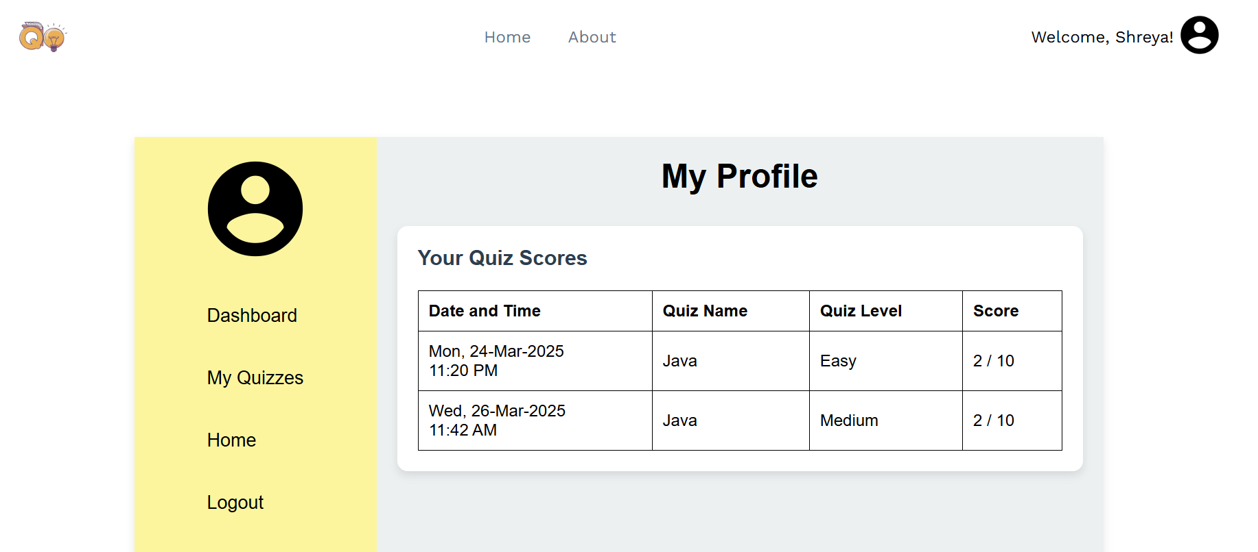

4.2 Output Screens with data

4.3 Data Reports

1. Introduction
This section presents the consolidated data reports generated from the execution of test cases for the Quizoria website. The reports highlight the number of test cases executed, their outcomes, and areas requiring improvement. The purpose is to provide a clear overview of system quality, reliability, and performance.

2. Test Execution Summary
Test Category | Total Test Cases | Passed | Failed/Needs Fix | Success Rate
Black Box Testing | 09 | 09 | 00 | 100%
Data Validation | 07 | 07 | 00 | 100%
White Box Testing | 09 | 08 | 01 | 88.9%
Functional Validation | 08 | 08 | 00 | 100%
Overall | 33 | 32 | 01 | 97%

3. Defect Report Summary

Defect ID | Module Affected | Description | Severity | Status
DEF_001 | User Authentication | Multiple failed login attempts not locking account | High | Needs Fix

4. Observations
- Strengths:
  - Functional correctness validated across all modules.
  - Data integrity maintained in SQLite/MySQL operations.
  - UI/UX consistent across devices and browsers.
  - Security measures (SQL Injection prevention, unauthorized access control) passed successfully.

4.4 Test Procedures and cases

1. Introduction
This test plan outlines the strategy, objectives, scope, test cases, methodologies, and expected results for testing the Quizoria website. The testing ensures that the system is functional, secure, and user-friendly, validating both internal code structure (White Box Testing) and functional behavior (Functional Validation Testing).

2. Objective
The primary objectives of testing the Quizoria website are:
- Verify functional correctness of all modules.
- Ensure data integrity in MySQL database operations.
- Validate UI/UX consistency across different devices.
- Check system security against unauthorized access.
- Confirm performance efficiency under varying loads.

3. Scope
Modules to be Tested:
- User Management (Registration, Login, Logout)
- Quiz Module (Quiz selection, level selection, play quiz, scoring)
- Progress Tracking (User achievements, progress updates)
- Leaderboard System (Ranking system, real-time updates)
- Navigation & UI (Responsiveness, mobile-friendliness)
- Database Operations (Data retrieval, storage, and validation)

4. Test Strategy

- Test Environment
Component | Technology Used
Frontend | HTML, CSS, JavaScript
Backend | Java
Database | MySQL
Testing Tools | Selenium (UI Testing), Postman (API Testing)

- Test Approach
- Manual Testing → For UI, usability, and functional validation.
- Automated Testing → For database queries and API validation.
- Regression Testing → Ensures new features do not break existing features.

Black Box Testing / Data Validation Test Cases

1. Introduction
This section presents the Black Box Testing and Data Validation Test Cases for Quizoria.

2. Black Box Testing Test Cases
- User Registration Module

Test Case ID | Scenario | Test Input | Expected Output
BB_001 | Register with valid details | Username: abc, Email: jhn22@gmail.com, Password: abc@2238 | User successfully registered
BB_002 | Register with an already existing email | Email: jhn22@gmail.com | “Email already exists” error message
BB_003 | Register with weak password | Password: 1234 | “Password must be at least 6 characters” error
BB_004 | Register with invalid email format | Email: john.example.com | “Enter a valid email address” error
BB_005 | Register with empty fields | Username: (blank), Email: (blank) | “Fields cannot be empty” error

- User Login Module

Test Case ID | Scenario | Test Input | Expected Output
BB_006 | Login with valid credentials | Email: jhn22@gmail.com, Password: John@2238 | User successfully logged in
BB_007 | Login with incorrect password | Email: jhn22@gmail.com, Password: Wrong pass | “Incorrect Password” error
BB_008 | Login with unregistered email | Email: Random@gmail.com, Password: Pss233 | “User not found” error
BB_009 | Login with empty fields | Email: (blank), Password: (blank) | “Fields cannot be empty” error

3. Data Validation Test Cases

- User Registration Data Validation

Test Case ID | Scenario | Test Input | Expected Output
DV_001 | Validate correct email format | jhn22@gmail.com | Accepted
DV_002 | Validate incorrect email format | john.example.com | “Enter a valid email address” error
DV_003 | Validate password complexity | John@2238 | Accepted
DV_004 | Validate short password | Abs | “Password must be at least 6 characters” error
DV_005 | Validate duplicate email entry | jhn22@gmail.com | “Email already exists” error

- Database Integrity Validation

Test Case ID | Scenario | Test Input | Expected Output
DV_006 | Validate user entry in database | Registered user | Exists in users table
DV_007 | Validate leaderboard data update | User plays quiz & earns score | Leaderboard reflects new score

White Box Testing / Functional Validation Test Cases & Results

- Introduction
This section covers White Box Testing and Functional Validation Test Cases for Quizoria.

1.White Box Testing Test Cases

- User Authentication (Login & Registration)
Test Case ID | Scenario | Test Steps | Expected Result | Status
WB_001 | Validate password encryption | Check if passwords are stored hashed in DB | Passwords must not be plain text | Pass
WB_002 | Validate SQL query for login | Execute SELECT * FROM users WHERE email=? | Returns correct user details | Pass
WB_003 | Check multiple failed logins | Enter incorrect password 5 times | Account should be temporarily locked | Needs Fix
WB_004 | Validate session management | Login → delete session cookies → refresh | User must be redirected to login | Pass

- Security Testing

Test Case ID | Scenario | Test Steps | Expected Result | Status
WB_005 | Test SQL Injection | Input ' OR '1'='1 in login form | System should prevent SQL Injection | Pass
WB_006 | Test unauthorized API access | Access /admin without login | Should redirect to login page | Pass

2.Functional Validation Test Cases

- User Registration

Test Case ID | Feature | Test Steps | Expected Result | Status
FV_001 | Registration with valid inputs | Enter valid details | Account created successfully | Pass
FV_002 | Registration with duplicate email | Enter existing email | “Email already exists” | Pass
FV_003 | Registration with weak password | Enter 1234 | “Password must be at least 6 characters” | Pass

- Login

Test Case ID | Feature | Test Steps | Expected Result | Status
FV_004 | Login with correct credentials | Enter valid email & password | User logged in | Pass
FV_005 | Login with incorrect password | Enter wrong password | “Incorrect password” | Pass
FV_006 | Login with unregistered email | Enter non-existing email | “User not found” | Pass

- Logout & Session Management

Test Case ID | Feature | Test Steps | Expected Result | Status
FV_007 | Logout functionality | Click Logout | Redirect to login page | Pass
FV_008 | Auto-logout on session timeout | No activity for 10 mins | User auto logged out | Pass

4.Test Results Summary

Test Category | Total Test Cases | Passed | Failed / Needs Fix
White Box Testing | 09 | 08 | 01
Functional Validation | 08 | 08 | 00
Total | 17 | 16 | 01

4.5 Sample program code

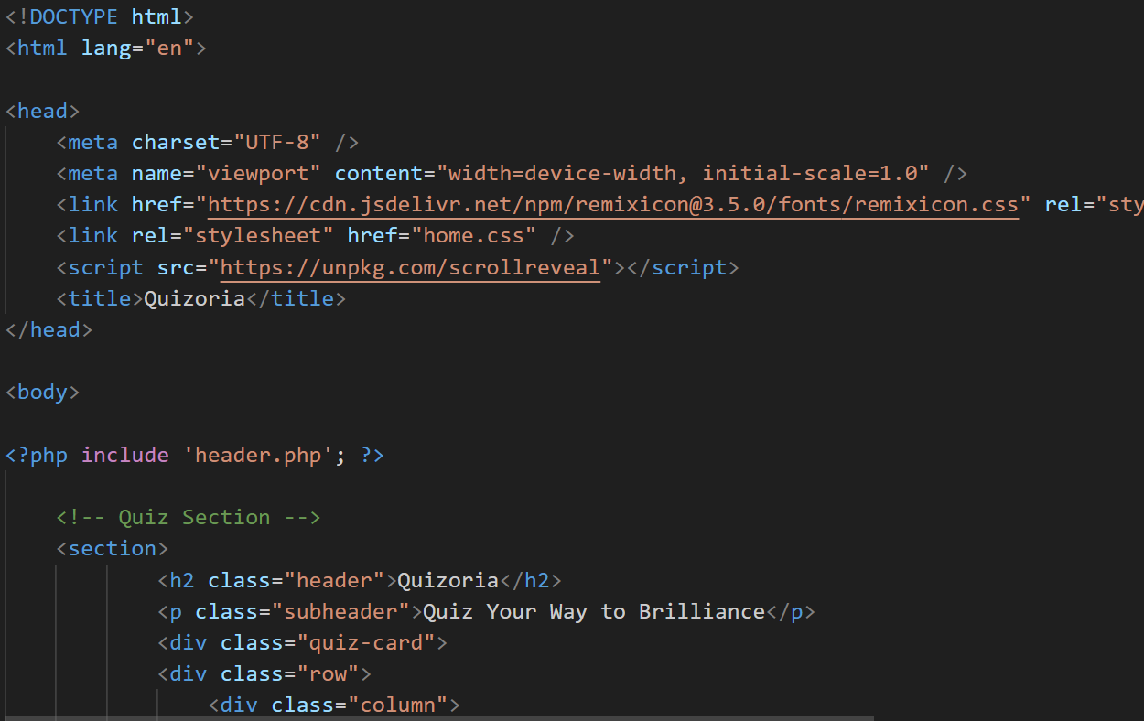
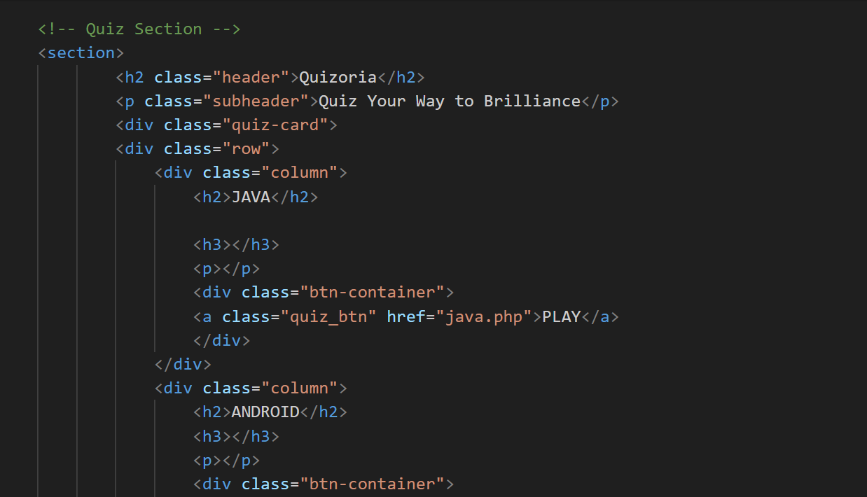
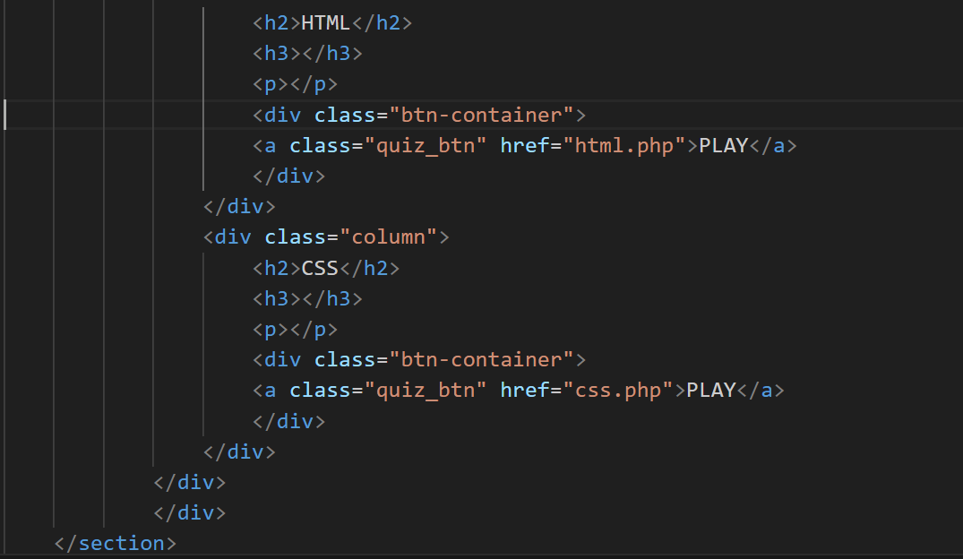

4.6 Limitations and Bibliography

- Limited topics: Currently, you only have 4 topics of programming languages, which might not be enough to cater to a wide range of users.

- Lack of personalized feedback: Users might not receive personalized feedback on their performance, which could limit their ability to identify areas for improvement.

BIBLIOGRAPHY

LINKS REFERED: -
For HTML, CSS and JavaScript: www.w3school.com
For Login Page:https://w3codepen.com/html-css-login-form-page/
HTML and CSS: Design and Built Websites by Jon Duckett

